**Case study**

**Microsoft Research’s FarmBeats: AI, Edge & IoT for Agriculture**

**Microsoft as a company**

With a mission to “empower every person and every organization on the planet to achieve more“**[1]**, Microsoft “enables digital transformation for the era of an intelligent cloud and an intelligent edge” **[1]**.

Founded in 1975 by William H. Gates III, Microsoft transitioned from being a seller of software licenses with roughly 80 percent of its revenue in 2004 coming from their flagship products Windows, Windows Server and Office Suite, to becoming a leader in cloud-based services with the motto of ‘mobile first, cloud first’ **[2]**.

With three core Engineering groups: Cloud + AI group, Experiences + Devices, Artificial Intelligence and Research, the company possess a wide range of online, software and enterprise-scale products such as Bing, Cloud Computing, Dynamics 365, IoT, Office, Office Servers, Skype, Windows, the new range of Surface laptops, and AI voice assistant Cortana.

While primary competitors include Amazon, Google and Apple amongst others, there are predictions**[3]** that Microsoft’s increasing focus on “inclusive design” and its efforts to contribute to differently abled people through tech such as Eye Tracking in Windows 10, Emma Watch, Seeing AI will help push its inclusion efforts to the forefront.

**Microsoft Research’s AI for Good**

Microsoft, as part of its commitment to provide technology, resources and expertise to support people and organizations working towards sustainability and accessibility has three broad initiatives where it’s utilizing Artificial Intelligence technologies for social good:

**AI for Earth** – tackling global environmental challenges

**AI for Accessibility** – amplifying human capability for people with disability

**AI for Humanitarian Action** – disaster recovery, addressing the needs of children and displaced people and human rights

There are four main areas of focus for AI for Earth:

|  |  |  |  |
| --- | --- | --- | --- |
| Climate | Agriculture | Biodiversity | Water |

As part of this case study, let us talk about an important initiative that falls under the umbrella of “**Agriculture**”. Microsoft Research is now working on a solution to tackle the world’s food scarcity by using data-driven farming. The initiative is called **FarmBeats**.

**Background**

If we look at the **United Nations** **#Envision2030** goals**, Goal 2: Zero Hunger** mentions that we as citizens of the world need to “End hunger, achieve food security and improve nutrition and promotesustainable agriculture”**[6]**

Below are key factors contributing to the current food shortage:

* Limited amount of arable land and receding water levels
* Non-technology mindset of the farmers and lack of basic technology infrastructure
* Irregular climate conditions, floods or droughts

**The various Lenses**

While the Governments want to gather accurate data on the farming ecosystem to drive sustainable agricultural and better economic policies for farmers, a Farmer wishes for assistance on raising crops or animals and effective utilization of Fertilizers while not adding to his existing workload. Other market forces wish for proper or competitive pricing. In this ecosystem, most parties encourage a solution that can increase crop yield.

**Opportunity with AI Technology**

Bill Gates, in his blog GatesNotes**[8]** asked an interesting question: Can the Wi-Fi chip in your phone help feed the world? Several innovative farm-data initiatives have experimented to apply technology to improve farming but have failed on certain counts. FarmBeats seems to provide a different answer to this global problem.

**FarmBeats**

It is a low-cost data-driven end-to-end IoT platform for farms which utilizes Machine Learning and the farmers` knowledge and intuition about their farms and provides key recommendations to the farmer, which coupled with the farmer’s intuition leads to increased yield and leaner agriculture. Its objective is tohelp double the crop yield by 2050 using technology and low-cost underlying infrastructure.

**Why do typical farm-technology solutions fail?**

Farms are often located in remote areas where network companies have no or little incentive to provide internet connectivity. Most farm-solutions build their own connectivity using expensive transmitters which is a big investment and non-sustainable for most farmers.

Any farm that collects data must use 1 in-soil sensor for every 10 metres of land covered and each sensor costs hundreds of dollars. So, the total cost of coverage is tremendous.

Providing accurate and actionable recommendations is a challenging task for any solution and has a direct impact on a farmer’s Trust on Technology.

**Product Innovation and AI Research that FarmBeats brought in**

To resolve connectivity challenges, the researchers found an innovative solution to use TV Whitespaces (the “snow” that you see while changing TV channels) to connect the farm with the Microsoft servers. The government has allowed its use for this purpose.

To overcome the high cost of sensors, they came up with an innovative architecture – Sensors need to be placed at every 100 metres rather than every 10 metres, and they propose to use Imaging data captured either via a single Drone flight over the farm or by using low-cost helium balloons if farmers can’t buy Drones. The sensor and image data are then “stitched” together using AI and Machine Learning to get a “Precision Map” of the farm, which is then processed to provide recommendations to the farmer.

To enable a local independent setup at the farm, FarmBeats recommends the use of Solar Panels to power their system and all processing happens at a local computer on the farm. At certain intervals, the data is uploaded to Microsoft Cloud to get advanced insights. (Exhibit 1)

**How does a farmer benefit from FarmBeats?**

The farmer can now access farm-insights on his/her Smartphone. The precision map could be used to see areas that need water. The Micro-Climate Prediction helps predict wind direction and speed, ambient temperature and humidity. Leaf wetness data though not collected can be predicted. Insights about when to plant, which crop is right at what time leads to an increase in productivity hence closing that global crop yield gap. If the farmer misjudges the soil moisture (because sometimes the soil looks dry at the top but is wet down under), it translates to applying Fertilizers at the wrong time and applying again. Getting accurate soil moisture insights lets the farmer save on Fertilizer costs. The farmer also benefits from Cross-Farm Analytics by utilizing tried and tested methods implemented at other farms.

**The Prototype that went live – Evaluation of its Impact**

The initiative was a game-changer for the “Dancing Crow Farm” in Carnation, Washington, the pilot site. The impact was as below:

* Up to 30% lesser water for irrigation
* 44% less lime to control soil pH
* Better timing of seed plantation – more productive harvest
* Insights on Flooding patterns helped the farmer understand when to plant and where
* Acquired ability to identify where inadequate drainage was affecting beans quality

**Challenges at hand**

Although FarmBeats reduces cost, the cost is still high for mass public adoption, especially in underdeveloped countries. The technology uses Solar energy as a power source, which may not be viable or will be more expensive in countries with less sunlight. There is also an ethical component to the ownership of the farmer’s data and the commercial exploitation once this scales to many farms. From an implementation and maintenance perspective, the deployments are 6 months long before the system and a successful implementation involves changing the mindset of the farmers to embrace technology.

**Foray into the future**

The research team recently published a paper that explains the ‘theoretical’ utilization of the phone wifi signals and low-priced RFID tags buried in the ground to be able to get soil data, with no special equipment required.

Bill Gates asked the question so that his team could answer it!

**Exhibit 1**

**Model Architecture - FarmBeats**

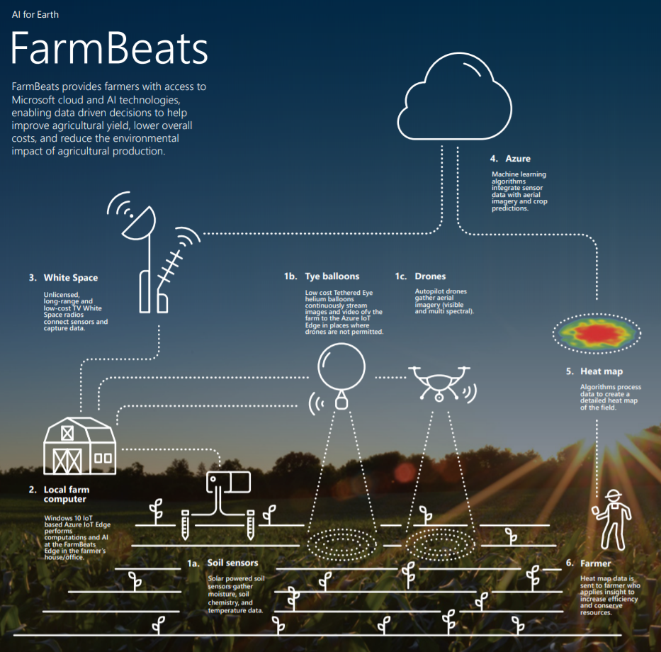

**Assignment References:**

**[1]** <https://news.microsoft.com/facts-about-microsoft/>

**[2]** <https://www.zdnet.com/article/microsofts-transition-to-the-cloud-picks-up-steam/>

**[3]** <https://www.windowscentral.com/jasons-extreme-2019-predictions-tech-and-microsoft>

**[4]** <https://www.microsoft.com/en-us/ai/ai-for-good>

**[5]** https://www.microsoft.com/en-us/ai/ai-for-earth?activetab=pivot1%3aprimaryr6

**[6]** <https://www.un.org/development/desa/disabilities/envision2030-goal2.html>

**[7]** <https://www.economist.com/science-and-technology/2016/09/17/tv-dinners>

**[8]** <https://www.gatesnotes.com/Development/FarmBeats>

**[9]** <https://www.microsoft.com/en-us/research/video/farmbeats-empowering-farmers-with-low-cost-digital-agriculture-solutions/>

**[10]** FarmBeats_Infographic_091318.pdf

**[11]** <https://www.microsoft.com/en-us/legal/intellectualproperty/trademarks/usage/logo.aspx>